***PROJECT REPORT***

***on***

***STUDENT MANAGEMENT SYSTEM***

*(Btech AI&DS VI Semester Mini project)*

*2020-24*



***Submitted to: Submitted by****:*

*Department of Computer Applications**Ayush Rawat(05)*

*University Roll Number: 2017639*

*Under the guidance of* ***Mr. Yuvraj Joshi***

*DEPARTMENT OF COMPUTER SCIENCE AND INFORMATION TECHNOLOGY*

***GRAPHIC ERA DEEMED TO BE UNIVERSITY, DEHRADUN***

***DECLARATION***

# I, Ayush Rawat student of B-tech, Semester 6, Department of Computer Science and Engineering, Graphic Era Deemed To Be University, Dehradun, declare that the technical project work entitled “Student Management System ” has been carried out by me and submitted in partial fulfillment of the course requirements for the award of degree in B-tech of Graphic Era Deemed To Be University during the academic year 2023-24. The matter embodied in this synopsis has not been submitted to any other university or institution for the award of any other degree or diploma.



***ACKNOWLEDGEMENT***

I would like to take this opportunity to express my gratitude to entire faculty at Department of Computer Science and Information Technology, Graphic Era Deemed To Be University, Dehradun who evaluated the project from time to time and gave me the valuable suggestions as to how to improve the project.

I am grateful to **Mr. Yuvraj Joshi** , Graphic Era Deemed To Be University, for his supervision, encouragement, inspiration, and guidance. Working under him is being an enriched experience. In all, I found congenial work environment in Graphic Era University, Dehradun and this project completion will mark a new beginning for me in the coming days.

I am highly indebted to Graphic Era University for providing me the required infrastructure and facilities to accomplish the given task.

Ayush Rawat

Btech AI&DS

2020-24

Graphic Era University

* ***Table of Contents***

**S.No Description Page No.**

1. Problem Statement and Motivation 5

2. Tools and Languages Used 6

3. Methodology and Features 7

4. Project Insights 8

5. Future Work and Conclusion 9

6. References 10

***Student Management system***

* ***Problem Statement***

The objective of this project is to develop a Student Management System that allows administrators and teachers to manage student records and calculate their results based on their marks. The system will provide a user-friendly interface for administrators to manage student information and for teachers to enter marks and for students to see their results or details. The calculated results will be stored in a database and can be accessed by both administrators and students. Languages used are PHP, SQL, CSS, Javascript.

* ***Motivation***

The development of a Student Management System with Result Calculation is driven by the need for efficient and effective management of student records, as well as accurate and timely result calculation. Some key motivations are:

1. **Efficiency and Accuracy:** Traditional methods of managing student records using paper-based systems or spreadsheets can be prone to errors. By implementing a Student Management System, educational institutions can centralize and organize student data, making it easily accessible and manageable for administrators, teachers, and students.
2. **Data Centralization:** Educational institutions often deal with large volumes of student data. Having a centralized system allows for easy access to student information, including grades, marks, and academic history. This ensures that data is organized, secure, and readily available when needed.
3. **Time and Resource Optimization:** By automating result calculation and management, valuable time and resources can be saved. Teachers can focus more on providing quality education and personalized guidance to students, rather than spending significant time on manual administrative tasks.

* ***Tools Used***

**XAMPP**:

XAMPP is a software package that includes Apache, MySQL, PHP, and Perl. It allows developers to create a local web server environment for testing and developing web applications without the need for a live server, making it a popular choice for web development projects.

**Visual Studio Code IDE**:

Visual Studio Code (VS Code) is a popular, free source code editor developed by Microsoft. It offers a lightweight and customizable environment with support for various programming languages. It includes features like syntax highlighting, debugging, Git integration, and an extensive marketplace for extensions, making it highly versatile for developers.

* ***Languages Used***

1. **HTML**: Markup language for structuring web content.
2. **CSS**: Stylesheet language for styling of the content, designing the presentation and layout of web pages.
3. **Java Script**: Programming language for adding interactivity and dynamic behaviour to web pages.
4. **SQL**: Language for managing and manipulating relational databases.
5. **PHP**: Server-side scripting language for creating dynamic web applications and interacting with databases.

* ***Methodology***

The project will be implemented using PHP, SQL, and JavaScript. The following steps will be followed to achieve the objectives:

1. **Requirements Gathering**: Gather the requirements for the Student Management System, including features such as admin login, student login, student record management, and result calculation.

2. **Database Design**: Design the database schema to store student information, marks, and calculated results.

3. **User Interface Design**: Design the user interface for the admin and student login screens, as well as the screens for managing student records and entering marks.

4. **Backend Development**: Implement the server-side logic using PHP. This includes handling user authentication, managing student records, and calculating results based on the entered marks.

5. **Frontend Development**: Develop the user interface using HTML, CSS, and JavaScript. This includes creating forms for data entry and displaying results to the users.

6. **Database Integration**: Integrate the database with the PHP backend to store and retrieve student information, marks, and results.

* ***Features:***

The Student Management System will include the following features:

1. **Admin Login:** Administrators will have a secure login to access the system and manage student records.

2. **Student Login:** Students will have their own login credentials to access their personal information and results.

3. **Student Record Management:** Administrators can add, update, and delete student records, including personal details and academic information.

4. **Mark Entry:** Teachers or administrators can enter marks for each student for different subjects or exams.

5. **Result Calculation:** The system will calculate the overall result of each student based on the entered marks and store it in the database.

6. **Result Display:** Students will be able to view their results by logging into their accounts.

* ***Project Insights***

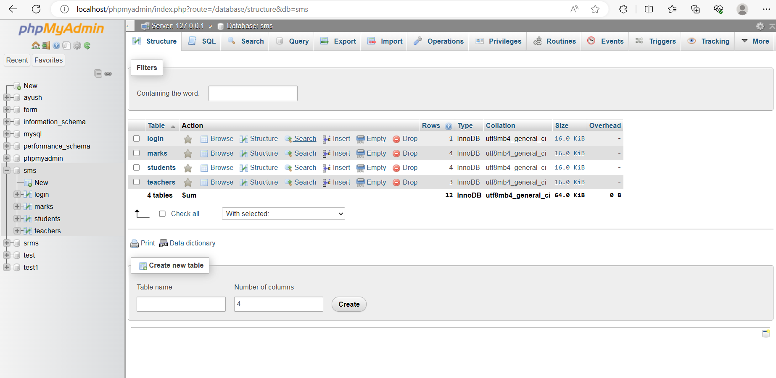

Tables of database in Xampp server.

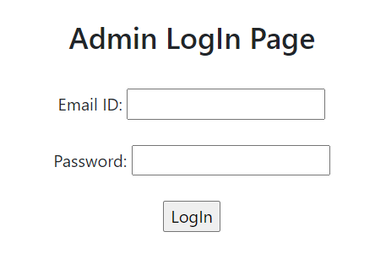 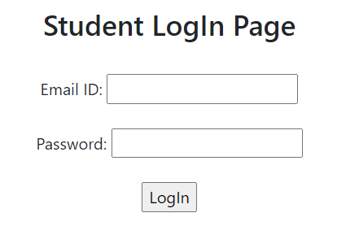

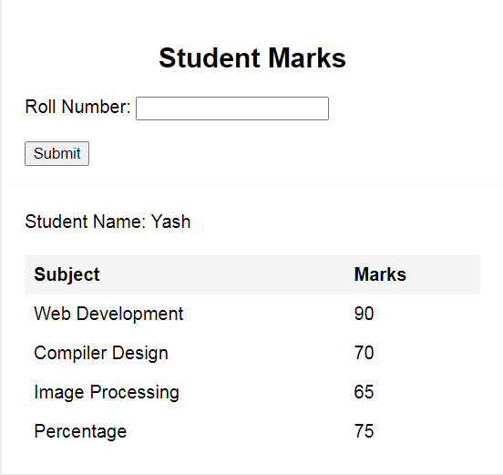

Result Calculation of a student.

* ***Future Work***

While the initial implementation of the Student Management System will include the core features mentioned above, there are several potential areas for future enhancements and improvements. These include:

1. **Advanced Result Analysis:** Implement additional features to analyze student results, such as generating graphical representations of performance, generating reports, and identifying trends.

2. **Automated Notifications:** Integrate an automated notification system to inform students and parents about their results, upcoming exams, or important announcements.

3. **Parental Access:** Extend the system to allow parents to access their child's academic information and results.

4. **Attendance Management:** Introduce a feature to track student attendance and generate reports for administrators and teachers.

* ***Conclusion***

The Student Management System developed using PHP, SQL, and JavaScript provides an efficient and user-friendly platform for administrators, teachers, and students to manage student records and calculate results. By implementing this system, educational institutions can streamline their student management processes and provide timely and accurate results to students. The future enhancements and improvements discussed above will further enhance the functionality and usefulness of the system, making it an invaluable tool for educational institutions.

* ***References***

During the development of this project, the following resources were referenced:

1. W3Schools - [https://www.w3schools.com](https://www.w3schools.com)

2. PHP Manual - [https://www.php.net/manual](https://www.php.net/manual)

3. SQLZoo - [https://sqlzoo.net](https://sqlzoo.net)

4. MDN Web Docs - [https://developer.mozilla.org](https://developer.mozilla.org)

5. Stack Overflow - [https://stackoverflow.com](https://stackoverflow.com)

6. From various youtube videos.

These resources provided valuable information and examples related to PHP, SQL, JavaScript, HTML, and CSS, which were crucial for the successful implementation of the Student Management System.